TASK 6 – EVALUATE THE COST OF SYSTEM CALLS

1. Aim
To evaluate the cost of system calls by comparing different buffer sizes during file-copy operations and measuring system-call frequency and execution time.

2. Introduction
System calls allow applications to request services from the operating system kernel.
However, system calls introduce overhead because the processor must transfer control between user mode and kernel mode.
The number of system calls can affect program performance.
A larger buffer can transfer more data in a single operation and reduce the number of read() and write() calls.

3. Experimental Setup
The experiment was performed using Kali Linux.
Component | Configuration
Operating System | Kali Linux
Compiler | GCC 15.2.0
Tracing Tool | strace 7.2
Measurement Tool | /usr/bin/time
Input File Size | 10,000 bytes
Buffer Sizes | 1, 512 and 4096 bytes

4. C Program for Buffer-Size Comparison
File Name: copy_file.c
#define _POSIX_C_SOURCE 200809L
#include <stdio.h>
#include <fcntl.h>
#include <unistd.h>
#include <stdlib.h>

long copy_file(const char *src, const char *dst, size_t bufsize)
{
char buf[8192];

int in = open(src, O_RDONLY);
if (in < 0) return -1;

int out = open(dst, O_WRONLY | O_CREAT | O_TRUNC, 0644);
if (out < 0) {
close(in);
return -1;
}

long calls = 0;
ssize_t n;

while ((n = read(in, buf, bufsize)) > 0) {
calls++;

ssize_t written = 0;

while (written < n) {
ssize_t w = write(out, buf + written, n - written);

if (w <= 0) {
close(in);
close(out);
return -1;
}

written += w;
}
}

if (n < 0) {
close(in);
close(out);
return -1;
}

close(in);
close(out);

return calls;
}

int main(void)
{
FILE *f = fopen("records.dat", "w");

if (!f) {
perror("fopen");
return 1;
}

for (int i = 0; i < 10000; i++)
fputc('A' + (i % 26), f);

fclose(f);

size_t sizes[] = {1, 512, 4096};

for (int i = 0; i < 3; i++) {
long calls = copy_file("records.dat", "copy.dat", sizes[i]);

if (calls < 0) {
perror("copy_file");
return 1;
}

printf("buffer %4zu bytes: %ld read() calls\n",
sizes[i], calls);
}

unlink("records.dat");
unlink("copy.dat");

return 0;
}

5. Compilation and Execution
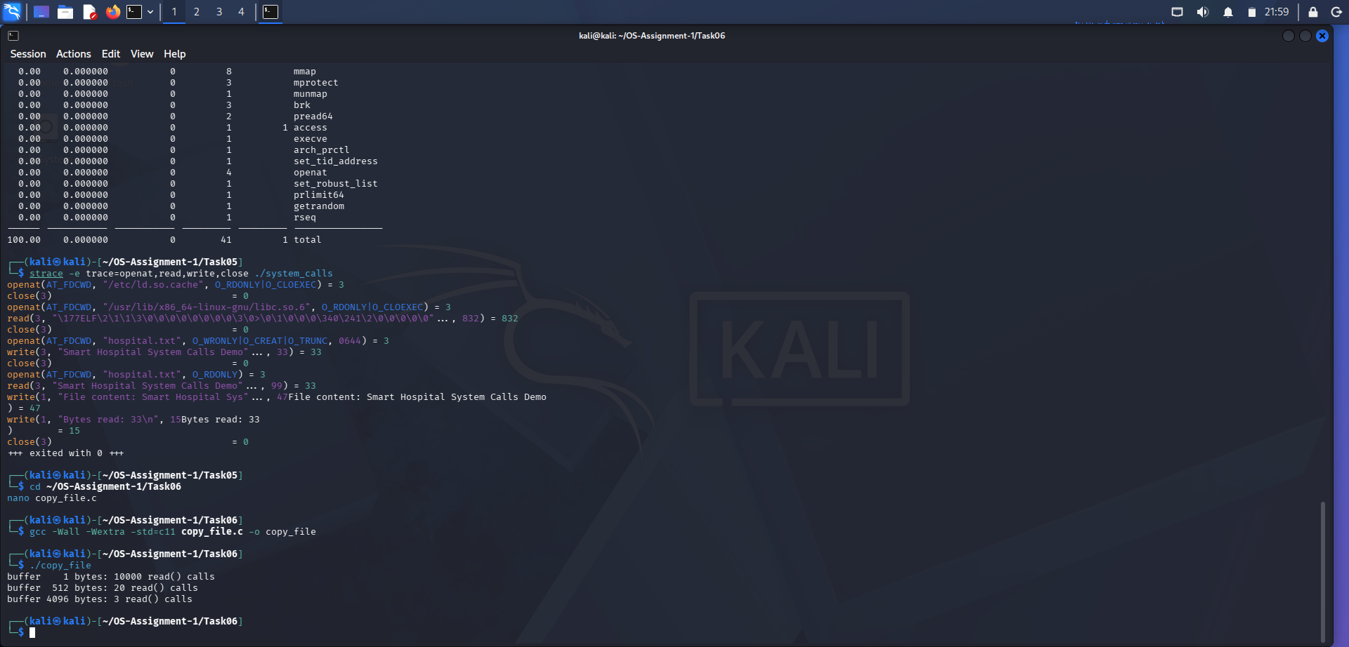
Compilation:
gcc -Wall -Wextra -std=c11 copy_file.c -o copy_file
Execution:
./copy_file

Actual Output
buffer 1 bytes: 10000 read() calls
buffer 512 bytes: 20 read() calls
buffer 4096 bytes: 3 read() calls

6. Buffer-Size Comparison
The actual program counts successful read() operations.
Buffer Size | Successful read() Calls
1 byte | 10,000
512 bytes | 20
4096 bytes | 3
The assignment's expected counts include the final read() call that returns zero to indicate End Of File (EOF).
Therefore, the EOF-inclusive counts are:
Buffer Size | Calls Including EOF
1 byte | 10,001
512 bytes | 21
4096 bytes | 4
Increasing the buffer size significantly reduces the number of successful read() operations.

7. Measuring System Calls Using strace
The following command was used:
strace -c ./copy_file

Actual System Call Summary
System Call | Number of Calls | Time (Seconds)
write | 10,029 | 0.053115
read | 10,027 | 0.049691
close | 9 | 0.000788
openat | 9 | 0.000170
unlink | 2 | 0.000053
Total | 20,105 | 0.103822
These are whole-program measurements covering all three buffer-size tests, including file creation, output, copying and cleanup.

8. Measuring Execution Time
The following command was used:
/usr/bin/time -v ./copy_file

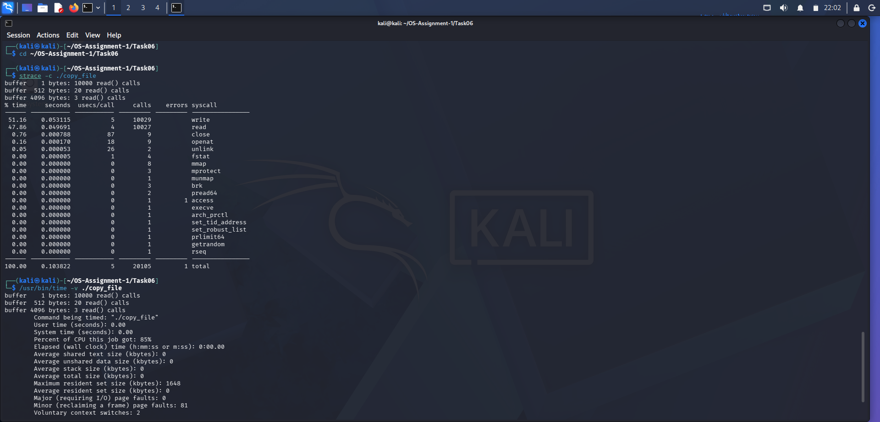

Actual Measurement Results
Measurement | Observed Result
User Time | 0.00 seconds
System Time | 0.00 seconds
CPU Usage | 85%
Elapsed Time | 0:00.00
Maximum Resident Set Size | 1648 KB
Major Page Faults | 0
Minor Page Faults | 81
Exit Status | 0
The program completed successfully without execution errors.
The elapsed time is rounded to 0.00 seconds because the test file is small. Therefore, this result is not sufficient for a precise performance comparison.

9. Alternative Concept – Memory-Mapped I/O
Memory-mapped I/O is an alternative method for accessing files using the mmap() system call.
It maps file contents into the virtual address space of a process.
Advantages:
- Reduces explicit read() and write() calls.
- Allows direct access to mapped file contents.
- Can be efficient for suitable large-file workloads.
- Avoids repeated application-level read buffers.
Limitations:
- Requires mapping and unmapping operations.
- Page faults may occur.
- Memory usage and page-cache behaviour must be considered.
- Performance depends on the workload and hardware.

Comparison
Feature | Buffered I/O | Memory-Mapped I/O
Main method | read() and write() | mmap()
Data access | Through a buffer | Through mapped memory
System calls | Repeated data-transfer calls | Fewer explicit data-transfer calls
Memory | Depends on buffer size | Depends on mapped region and resident pages
Complexity | Simple | More complex

10. Complexity Analysis
Time Complexity: O(n), where n is the size of the file.
Both buffered copying and memory-mapped copying must process the file data.
Space Complexity: O(b) for buffered copying, where b represents the buffer size.
Memory mapping reserves virtual address space for the mapped file, while physical memory is generally brought into use page by page.

11. Conclusion
The experiment demonstrated that buffer size has a major effect on the number of system calls.
A 1-byte buffer required 10,000 successful read() operations, while a 4096-byte buffer required only 3.
The strace utility helped measure system-call frequency, and the time command provided execution-time and memory information.
Therefore, using a larger buffer can reduce system-call overhead and improve file-copy efficiency.

